Year 1 – Homework activities including regular reading.
 | w/b 15.04.24 | w/b 22.04.24 | w/b 29.04.24 | w/b 06.05.24 | w/b 13.05.24 | w/b 20.05.24
English | Watch a video of the story Lost and Found by Oliver Jeffers, https://www.youtube.com/watch?v=cRAAQ8EWzig&t=74s  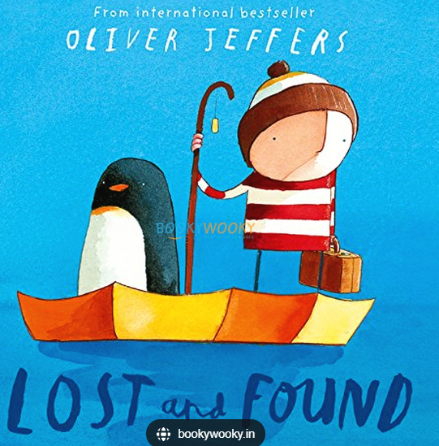  Write a book review.  What was the book about?  Did you like it? Why?  What was your favourite part? | Watch the story again. Have a look around your home. Can you find any lost animals? It could be a toy or a teddy!  Use your animal to make a lost poster. Don’t forget to write a title, question and description and draw a picture.  Example:  Lost!  Is this your cat?  It has black, soft fur. It has a long tail with a white tip. | Watch the story for a final time. Use your own ideas to make changes to the story.  Who will knock at the door?  How will they travel?  Where will they travel to?  What else might happen?  Write your story and draw pictures. | Watch a video of the story Pig the Pug by Aaron Blabey https://www.youtube.com/watch?v=NSRWqo_ZmJg  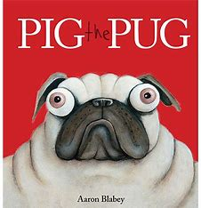  Write a book review.  What was the book about?  Did you like it? Why?  What was your favourite part? | Watch Pig the Pug again. Pig was not being a good friend. Write a guide for Pig to teach him how to be a good friend.  Example:  To be a good friend you need to share and take turns.  You need to use kind words and kind hands. | There are lots of different Pig books. You can find some of them on YouTube (with adult supervision). There is Pig the Monster; Pig the Rebel; Pig the Stinker.  Watch the story for inspiration. Then use your imagination to make up your own Pig story. Where will he go? What trouble will he cause? Will there be a happy ending?
Maths | Practise counting in 2s.  Can you write your 2s? You can use the 100 square on the next page to help you.  Do you notice any patterns? | Practice counting in 10s.  You can join in with this song:  https://www.youtube.com/watch?v=Ftati8iGQcs  Make a poster for your 10 times table. | Practice counting in 5s.  You can join in with this song:  https://www.youtube.com/watch?v=EemjeA2Djjw  What do you notice? | Use the 100 square on the next page to find out:  a) 1 less than 24  b) 1 less than 51  c) 1 more than 3 tens 6 ones d) 1 more than 39 | Draw a number line to 50.  Colour your 2s in one colour.  Colour your 10s in another colour. | Practice some simple adding and take away using numbers up to 20 e.g.  6 + 9 = 19 – 3 =  12 + 5 = 15 – 8 =  11 + 8 = 10 – 6 =
Wider  Curriculum | RE  We will be learning about sacred places.  Where do you feel safe?  Why is your safe place special to you?  Draw a picture of the place you feel safe and write about why it is special.  Have a look at BBC Bitesize: KS1: Religious Education https://www.bbc.co.uk/bitesize/subjects/zxnygk7 for videos and information about religions. | Geography  When walking around the local area talk about these questions:  What does our local area look like?  What types of buildings can we see?  What kind of jobs do people do here?  Draw and write about what you see. | Music  We have making up our own superhero names and theme tunes.  What is your superhero name?  Can you sing your name using a low and a high pitch?  Draw a picture of you as a superhero. Make up a story about an adventure you will have. Do you save the day? | DT  We have been making puppets! Design a puppet using things from around your home.  What materials will you need?  How will you make you puppet?  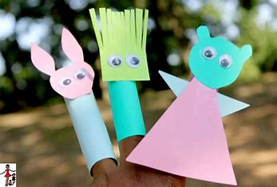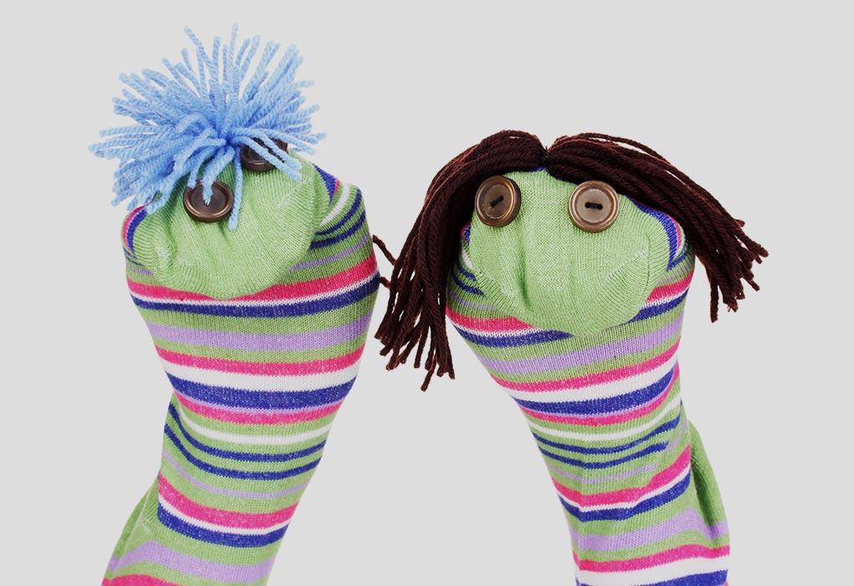 | PHSE  We have been talking about people who help us.  Who helps you outside of school?  How do they help you?  Make them a card to let them know how special they are and to say thank you for helping you 😊 | Science  Have a look at the information of BBC Bitesize: The parts of a plants: https://www.bbc.co.uk/bitesize/topics/zpxnyrd/articles/z2vhxbk  Draw a picture of a plant and label its parts. Include:  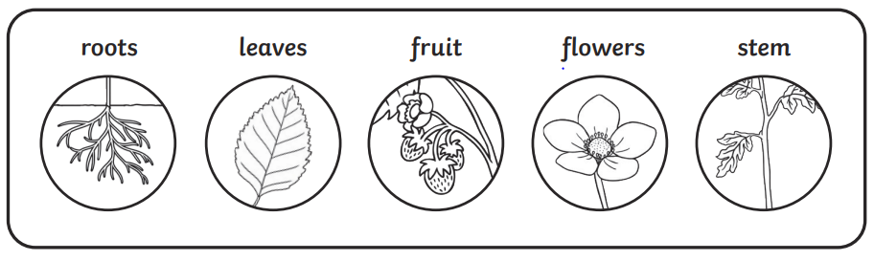

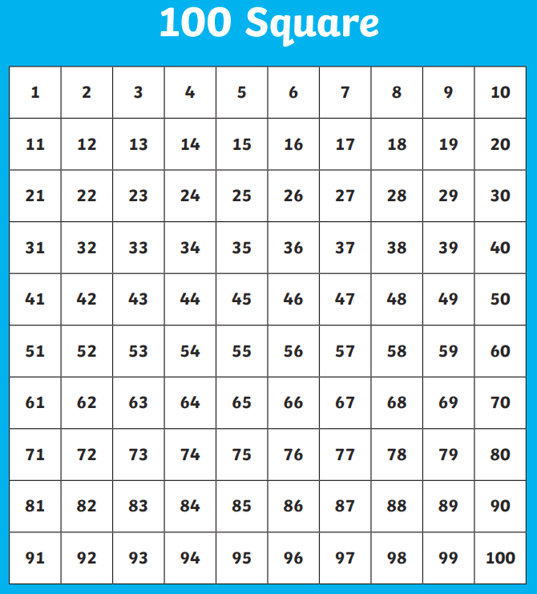
Spellings:
 | - I  - to  - go  - no  - the | - he  - she  - we  - me  - was  - all  - you  - are  - they  - here | - spoke  - when  - one  - what  - some  - out  - like  - have | - little  - so  - do  - were  - come | - where  - why  - because  - more  - other  - gone

Times tables:
Practise counting in steps of 2s | Practise counting in steps of 5s | Practise counting in steps of 10s | Practise counting in steps of 2s | Practise counting in steps of 5s | Practise counting in steps of 10s

