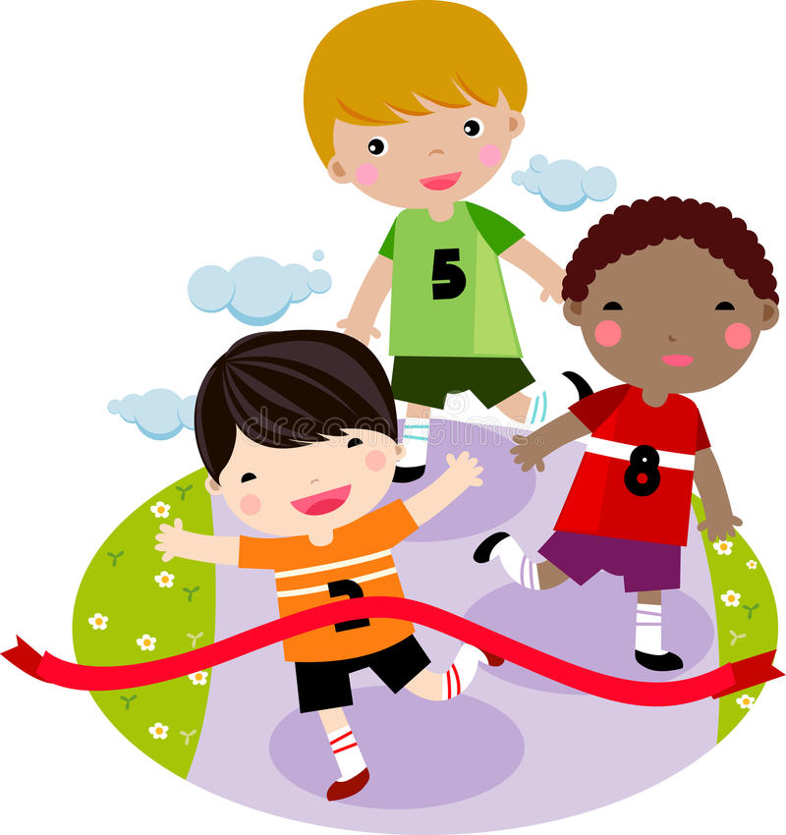

Physical Education

Children will:

* Have weekly indoor and outdoor PE lessons
* Explore movement and dance relating to a theme
* Practise controlling a ball with their hands

So that they…

Create a sequence of movements to music

Control a ball and participate in a range of games

Develop greater stamina and fitness

Music

Children will:

* Explore and copy rhythms with their hands and with instruments
* Listen to different instrument voices

So that they…

Develop an understanding of rhythm and timbre

Create a piece of music representing characters

PSHE

Children will:

* Explore the difference between healthy and unhealthy
* Give examples of healthy choices
* Discuss how to stay clean, healthy and safe

So that they…

Know some ways to keep healthy

Understand how to help themselves when they feel poorly

Recognise how being healthy makes them feel happy

Geography

Children will:

* Explore Beijing
* Compare London and Beijing
* Look at photos and videos of two contrasting cities
* Explore land use in the UK and China

So that they…

Develop their knowledge of the world

Understand basic geographical vocabulary relating to human and physical geography

Can talk about the similarities and differences of two areas

Maths

Children will:

* Explore multiplication as equal groups and as an array
* Explore division as grouping and sharing
* Begin to learn 2, 5, and 10 times tables
* Mesaure objects in cm and m
* Compare and measure the mass, volume and temperature
* Solve one and two step problems
* Talk about their maths and explain their answers

So that they...

Recall and use multiplication and division facts

Develop a range of strategies to model multiplication and division

Choose and use appropriate standard units to measure length, mass, temperature and volume

DT

Children will:

* Design a vehicle
* Measure and cut our components

So that they…

Know how to use jigs and handtools for safe, accurate cuts

Describe how their design will appeal to their client

Create a moving vehicle with safety features

Computing

Children will:

* Learn about E-safety
* Log on to Chrome books
* Group and sort data
* Record objects in a group and share information

So that they…

Understand how to stay safe online

Can use ICT to group data and present information

English

Children will:

* Explore the texts ‘The Owl and The Pussy-cat’ and ‘Tadpole’s Promise’
* Learn to use a range of prefixes and suffixes
* Develop rhyming skills
* Partake in discussions about specific questions relating to the texts we are reading
* Write explanations, letters, speech bubbles, poems, instructions and setting descriptions
* Form and re-read sentences accurately using success criteria
* Take part in Daily Supported Reading
* Have daily phonics or grammar lessons

So that they…

Verbally articulate their ideas clearly and confidently

Write and edit descriptive pieces of writing for a range of purposes

Form coherent sentences with a range of language features

Apply their phonics knowledge when writing and reading

Develop fluency and reading comprehension

**Healthy**

**Me**

Science

Children will:

* Conduct comparative tests
* Learn about reducing, reusing and recycling
* Investigate water and energy use
* Learn about endangered animals

So that they…

Understand some of the ways our environment is changing

Carry out simple tests using measuring equipment

Record and communicate findings from research and simple tests to share with others.

How You Can Help

* Support your child with their weekly homework (accessible on the Harbinger website)
* Encourage good hygiene and hand washing habits.
* Read every day with your child using BugClub or books that are sent home.