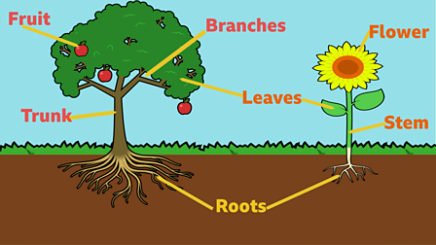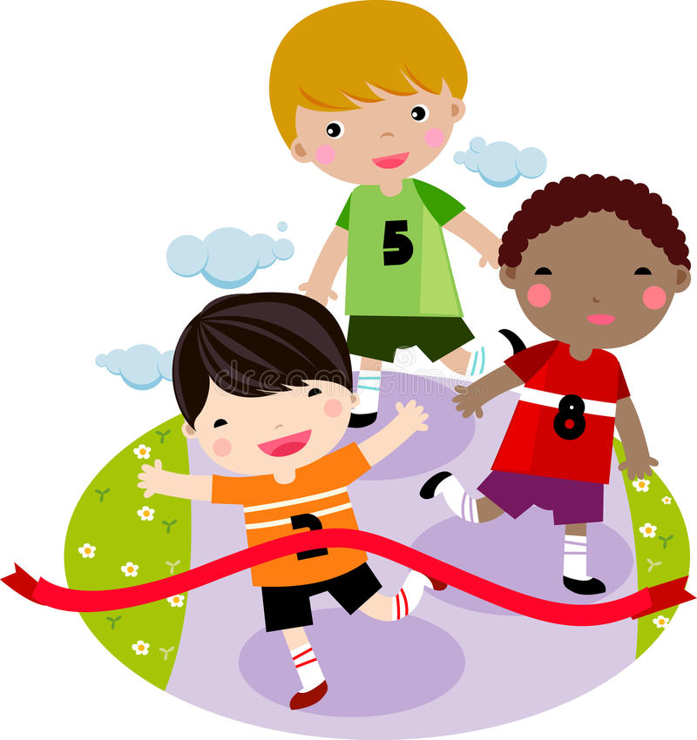

Maths

Children will:

* Comparing and measuring mass, volume and temperature
* Solving problems involving mass and capacity
* Read and write time on an analogue clock face including o’clock, half past and quarter past

So that they...

Estimate and measure mass (kg/g); temperature (°C); capacity (litres/ml) to the nearest appropriate unit, using scales, thermometers and measuring vessels

Compare and order mass, volume/capacity

Tell the time to the nearest 5 minutes, including, quarter past/to the hour

Draw the hands on a clockface to show these times.

Know the number of minutes in an hour and hours in a day.

Religious Education

Children will:

* Explore places of worship for Muslim and Christian people.
* Discuss similarities and differences between sacred places.

So that they…

Understand what makes some places sacred.

Physical Education

Children will:

* Have weekly indoor and outdoor lessons
* Explore team-building activities
* Develop athletic skills of running, jumping and throwing

So that they…

Develop ideas of sportsmanship and group work

Develop greater stamina and fitness

Science

Children will:

* Look at a range of seeds and bulbs
* Investigate what plants need to grow
* Label parts of a plant

So that they…

Observe and describe how seeds and bulbs grow in to mature plant

Find out and describe how plants need water, light and a suitable temperature to grow and stay healthy.

Geography

Children will:

* Explore the local area and the buildings
* Look at pictures and maps of the seaside
* Consider what it would be like to love by the sea

So that they…

Develop knowledge about the UK and the local area

Use geographical vocabulary relating to human and physical features of the sea

Understand that seaside towns are very different to big cities

PSHE

Children will:

* Talk about their families and who is in their family
* Think about friendships they have
* Consider What Makes a Good Friend

So that they…

Appreciate the positive relationships they have in their lives

Can identify qualities that make a good friend and ensure that they themselves are being good friends

Computing

Children will:

* Learn about E-safety and use chrome books
* Make marks with the shape and line tools
* Make choices about colour and style

So that they…

Use shape and line tools on a computer

Use a computer to paint a picture

**Growth**

Music

Children will:

* Explore pitch and tempo
* Create patterns using two pitches
* Create a superhero theme tune

So that they…

Compose and perform a group piece with a changing pitch and tempo, using voices and instruments

English

Children will:

* Explore ‘Into The Forest’, ‘The Tunnel’ and other texts by Anthony Browne
* Learn to use a range of prefixes and suffixes
* Create suspense and mystery with their writing
* Partake in discussions about specific questions relating to the texts we are reading
* Write setting and character descriptions, stories, explanations and poems
* Form and re-read sentences accurately using success criteria
* Take part in Daily Supported Reading
* Have daily phonics or grammar lessons

So that they…

Verbally articulate their ideas clearly and confidently

Write and edit descriptive pieces of writing for a range of purposes

Form coherent sentences with a range of language features

Apply their phonics knowledge when writing and reading

Develop fluency and reading comprehension

How You Can Help

* Support your child with their weekly homework (accessible on the Harbinger website)
* Encourage good hygiene and hand washing habits.
* Read every day with your child using BugClub or books that are sent home.