Teacher: Farzana Ruby Class Year: 4 Term: 3.1 2024

Maths

Children will:

* Continue to solve problems using their knowledge of fractions
* Learn about decimals which are equivalent to one half, one quarter and one tenth
* Revise written and mental strategies for addition, subtraction, multiplication, and division
* Solve word problems which have more than one step, using all four operations

So that they…

* Have a secure understanding of how

to read fractions

* Can confidently solve reasoning, problem solving and fluency questions using their   
  fractions knowledge
* Can calculate fractions of amounts

English

Children will:

* Read and discuss a range of books:

The Ever Changing Earth

Weslandia

The Last Firefox

* Study the content, layout and language features of persuasive brochures.
* Learn to write clear and detailed sentences using the ‘5 ws’
* Develop their knowledge of how and when to use the present perfect tense.
* Learn how to effectively take notes
* Further develop their ability to punctuate and write direct speech.
* Further develop their story telling and decription language skills.

So that they…

* Develop a love of reading
* Can write in a range of genres, for different purposed and audiences
* Are able to write detailed, descriptive pieces
* Know how to edit and improve their writing

History

Children will:

* Use their history lessons and reading lessons to find out about life in Ancient Rome
* Learn how the Roman Empire spread
* Find out how and why the Romans invaded England and the impact they had on the country
* Discuss what made the Roman Empire so powerful and successful

So that they…

* Develop an appreciation for   
  how the Romans changed life in   
  Britain
* Can carry out discussions about  
  their learning, using historical   
  evidence to support their ideas

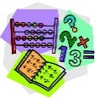

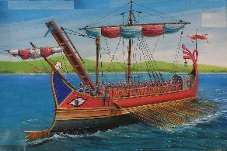

Science

Children will:

* Investigate how sounds are made and how

they travel through a medium to the ear

* Use instruments to find patterns between the pitch and volume of a sound and how to produce them
* Explore sounds getting fainter as the distance from the sound source increases
* Carry out a practical enquiry; recognise a fair test, make accurate measurements and draw conclusions

So that they...

* Know and understand how sound and vibrations operate in the world around them
* Can consider reasons needed to reduce and not reduce sounds
* Explain their findings using scientific language and writing

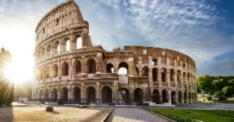

**Remarkable Romans!**



Art

Children will:

* Explore the work of international artists who use found and recycled materials
* Use recycled materials to create expressive and playful sculptures
* Work with pattern and colour
* Practice joining techniques to create sturdy pieces

So that they...

* Become familiar with Roman architectural style and recognise some famous Roman buildings
* Understand how to select and use a wide range of tools and equipment to perform practical tasks
* Develop their paper engineering skills

How You Can Help at Home

**Times Table Rockstars**: Please make sure children are practising their times tables regularly at home.

**Reading:** Please continue to read with your child at least **three times a week**. Children can borrow books from the classroom, the school library or plan a re-visit to the Idea Store! Reading diaries should be completed on our online padlet at _____ and homework should be brought in on **Fridays**.

**Homework** will be set every half term. Some homework will involve logging into Purplemash.

**PE:** PE takes place on **Tuesdays and Fridays** Children will need to come to school on these days wearing suitable PE clothing and trainers.

Computing

Children will:

* Learn how to code and program algorithms

So that they...

* Instruct a robot to perform a task