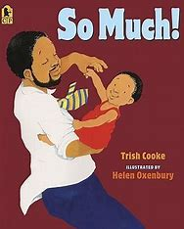
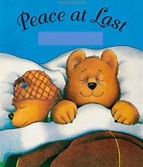

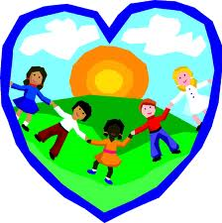
Ourselves

Events Trip to Young V & A Museum – 3rd July New Year one parent meeting – TBC Reception Graduation – TBC

How you can help at Home

- Talk to your child about moving into Year one in September.
- Read EVERY day and complete the reading diary twice a week.
- Complete the homework given every Friday and return to school every Wednesday.
- Ensure that your child has a bottle of water, hat and sun cream at school.
- Ensure that your child has a spare set of clothes so that they can take part in water play.
- Apply sun cream to your child before they come to school, please.

Understanding the World
Children will…
- Talk about what makes us human.
- Explore using their senses - taste, touch, hear, see and smell.
- Talk about parts of the body.
- Look at and talk about healthy and unhealthy foods.
- Compare themselves as babies and now.
So that they:
Know what makes us human.
Know the five senses.
Name parts of the body.
Understand the importance of a healthy diet.
Understand that humans grow and change.

Expressive Arts & design
Children will…
- Sing new songs about Eid and Ourselves.
- Recreate roles and experiences in our role play areas.
- Record/ represent themselves, their families and feelings through artwork.
So that they:
Perform songs using ‘What Makes a good performance’ criteria.
Speak about their thoughts and experiences.
Use their imagination.
Physical Development
Children will…
- Jump and roll in a range of ways from one space to another.
- Create sequences using different movements.
- Play group games involving control, co-ordination and turn taking.
So that they:
Jump and roll with control and balance.
Perform a sequence with confidence and control.
Take part in group games on Sports Day!

Communication & Language & Literacy
Children will…
- Talk about themselves
- Retell familiar stories
- Segment words to spell
- Learn to read and write common words
So that they:
Learn to use story language.
Can start to write down their own ideas.
Use their phonic knowledge when writing.
Apply word knowledge in reading and writing.

Personal, Social & Emotional Development
Children will…
- Talk about their own ideas in a large group.
- Take part in ‘Giant Club’.
- Look back at their time in Receptions.
So that they:
Share their ideas and opinions with others.
Express how they feel about moving to Year 1 including their worries and what they are looking forward to.
Share memories of their reception year.
Mathematics
Children will…
- Review previous learning of counting, number patterns, understanding and comparison.
So that they:
Consolidate previous learning.
Use their mathematical knowledge to solve a range of problems during practical activities.

