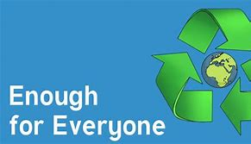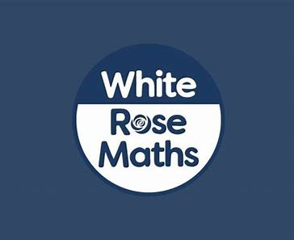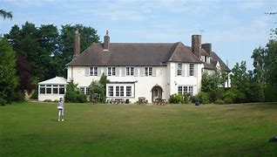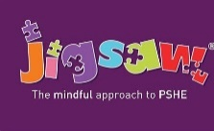

Residential Trip

Children will:

* Travel to and stay at Gorsefield

So that they...

Deepen their learning, explore new things and learn through authentic experiences.

Geography

Children will...

* Explain, identify and describe natural resources
* Understand fossil fuels and electricity
* Explore renewable energy
* Identify food sources
* Investigate water sources
* Answer an enquiry question

So that they…

know examples of renewable and non-renewable sources of energy ​

explain how electricity is generated in the UK​

describe the pros and cons of energy sources

Science

Children will:

* Describe the major stages of a human life​
* Explore the rapid changes that happen in the 1st year of human life​
* Record data and results of increasing complexity using bar and line graphs​
* Explore the effects of old age on the human body. ​
* Learn about the gestation period of humans. ​
* Compare animal gestation periods with their life expectancy. ​

So that they can:

compare graph types and select which is most appropriate for my data. ​

analyse and report findings in written explanations. ​

name the 6 stages of human development.​

Computing

Children will continue to:

* Take part in a Dragon’s Den scheme run by HSBC
* Design and develop a project, creating a unique technological item
* Work with their peers to present their design to a panel of judges

So that they…

* Continue to develop their teamwork and leadership skills
* Develop a greater understanding of product design in the computing sector

Maths

Children will:

* Explore the relationship between fractions, decimals and percentages
* Order and compare decimals with up to 3 decimal places
* Understand rounding
* Understand percentages
* Explore the perimeter of rectilinear shapes and polygons
* Explore the area of rectangles and compound shapes
* Estimate area
* Draw, read and interpret line graphs, tables and timetables
* Continue to practise mental arithmetic strategies
* Develop maths mastery through problem solving and reasoning questions

So that they...

deepen and extend their knowledge and understanding of fractions, decimals and percentages

extend their understanding of the number system and place value, including decimal numbers.

deepen their understanding of perimeter and area

build on their knowledge of statistics

understand a wide range of complex mathematical concepts and solve problems using a variety of skills and knowledge.

work quickly and efficiently.

Art

Children will:

* Explore current and previous plinth commissions
* Design their own Public Art sculpture
* Make and present a Public Art design ready for competition
* Explore Street Art and graffiti tags
* Experiment with meaning and message in Street Art

So that they...

know the differences and similarities between public art and street art

use various art media for specific effect

create a competition ready application for public art

Mystery and Truth

English

Children will:

* Read and understand ‘*High Rise Mystery’* by Sharna Jackson and *‘Curiosity- The Story of a Mars Rover’* by Markus Motum
* Read a variety of fiction and non-fiction texts and answer skills based comprehension questions
* Understand the purpose and audience of different writing genres
* Plan and write an extended story following the style of an author and an expanded explanation text based on ‘*Curiosity- The Story of a Mars Rover’*
* Learn and apply a range of Y5 grammar and spelling techniques
* Improve the legibility of their handwriting and accuracy of spelling
* Proofread, edit, and improve their writing according to Y5 expectations

So that they...

enjoy reading

develop and apply key reading skills

improve their reading fluency and stamina

consider the purpose and audience when planning their writing

assess the effectiveness of their and other’s writing

Develop their ability to communicate clearly and engage the listener.

Physical Education

Children will:

* Take part in cricket sessions **(Friday)**
* Take part in orienteering and team building sessions **(Monday)**

So that they...

consolidate their understanding and ability to effectively apply a range of batting and fielding skills and tactics in tournaments

develop important life skills like problem solving, listening, leadership, and creative thinking

develops higher levels of self-confidence, self-esteem, empathy, and compassion

PSHE

Children will:

* Take responsibility for their health and well-being
* Understand the impact of ant-social behaviour
* Develop a positive body image
* Explore motivation and how it links to behaviour

So that they...

understand what it is to be healthy

RE

Children will:

* Explore the enquiry question: **Is it better to express your religion in arts and architecture or in charity and generosity?**

So that they...

describe and make connections between examples of religious creativity (buildings and art)

show understanding of the value of sacred buildings and art

suggest reasons why some believers see generosity and charity as more important than buildings and art

Teacher: Nazmeen Akhtar Turquoise Class Forecast Year 5 Term 2:2 2024