

**Personal, Social and Emotional Development**

Children will learn to:

* I am beginning to solve minor conflicts and accept that no everyone can be chosen
* I am increasingly able to follow rules without adult reminders
* I am starting to listen to the ideas of others
* I can link my emotions to zones of regulation
* I can talk about some healthy practices
* I have high levels of well-being and involvement in my chosen activities
* I can self-select activities and ask for help when needed
* I can play in a group building on and elaborating ideas
* I can work as part of a team and am beginning to take into account others needs and feelings

**Communication and Language**

Children will learn to:

* I can respond to instructions with more than one element
* I can respond appropriately when engaging in communication during my play
* I can respond to simple comprehension questions about key texts and / or familiar experiences
* I can use new vocabulary in play and in small group sessions
* I can stick to a theme and ask simple questions
* I can communicate in front of a small group

**Maths**

Children will learn to:

* I can recognise numerals to 5
* I count with 1:1 correspondence to 5
* I can compare 2 quantities
* I am beginning to understand the cardinal principal (that a number represents an amount)
* I am beginning to recite numbers to 5 and beyond
* I can compare the height of 2 or more objects
* I can compare the length of 2 or more objects
* I know that balance scales can be used to compare weight
* I can explore volume and capacity and use some language to describe this

**Expressive Arts and Design**

Children will learn to:

* I explore a variety of creative materials to create an effect
* I can create musical patterns using instruments
* I am developing my imagination when playing with small world toys
* I am beginning to describe my thoughts and feelings in response to music

**Understanding of the World**

Children will learn to:

* I am beginning to make sense of my own life story and familys history
* I am beginning **to** know there are other countries in the world and how they differ or are similar to the UK
* I can talk about some of **the** ways people celebrate Easter and Holi
* I am beginning to learn about different countries around the world
* I know some of the signs of spring
* I can talk about changes I notice
* I am beginning to understand some of the key features of the life cycle of a sunflower / or other living things
* I am beginning to know some things needed to care for living things

**Physical Development**

Children will learn to:

* I can draw lines and circles using gross motor skills
* I can move skilfully avoiding obstacles
* I am beginning to use alternate feet when going up stairs
* I can copy some letters
* I can use my hands, fingers and other tools to create the desired effect when using play dough

**Book Bags and Reading**

Children need to be read to EVERY DAY. We change books on Mon and Thurs. You may change books using the blue box outside class.

* Turn the pages, talk about book features such as page numbers, blurb, author, recognise non-fiction
* Use the picture clues – predict what might happen
* Talk about the story – respond to simple questions

Creatures Great and Small

Moonstone Class Spring 2 2024

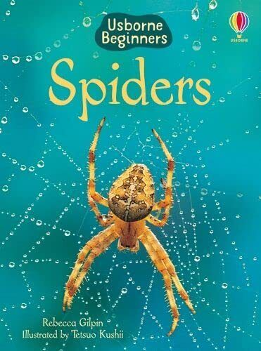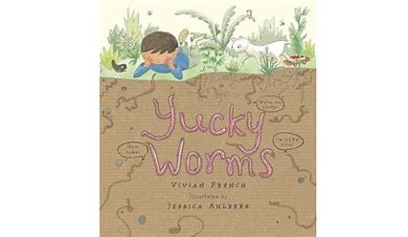

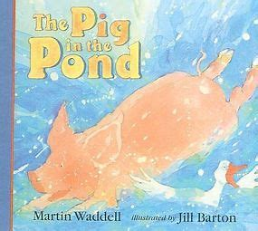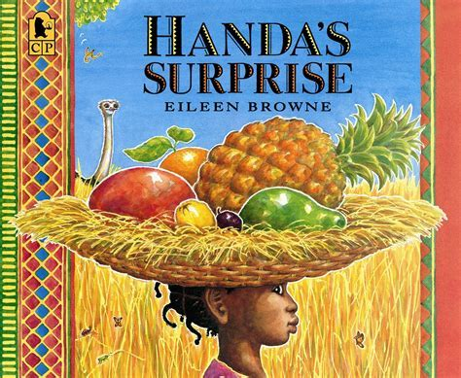

**Teams** 

Please read and contribute to our **Moonstone Class Teams channel**.

**Often, we need you to post a picture to help us with our learning or to make a display.**

Your childs login details are in the reading diary.

**Jigsaw – Healthy Me**

* I will make healthy choices
* I will eat a healthy balanced diet
* I will be physically active
* I will keep myself and others safe
* I will know how to be good friend and enjoy healthy friendships
* I will know how to keep calm and deal with difficult situations

**Literacy**

Children will learn to:

* I respond and react to illustrations, character and narrative from books
* I can retell parts of a familiar story using some of the vocabulary from the text
* I am beginning to use mark making / writing as a form of communication
* I am beginning to form some recognisable letters