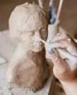
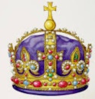
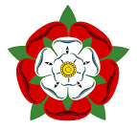
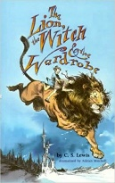
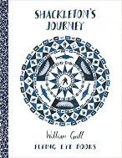





c
RE
Children will:
Learn about what faith looks like today.
So that they…
- Respect the beliefs
of others

Art
Children will:
- Explore different artists and their artistic styles
- Suggests ways to represent memories through imagery, shape and colour
So that they…
- Create a 3D sculpture to express themselves
PE
This half term, we will have outdoor PE every Tuesday and Thursday. We are learning Athletics, Orienteering and Team Problem Solving skills.
Children should come to school with a PE kit which they can change into that includes suitable shoes.

History
Children will:
- Learn about who the Tudors were and when they lived
- Find out how they lived and what they ate
- Explore what life for like for children at that time
- Investigate crime and punishment during that period
So that they…
- Know how the Tudor period began and how it developed over time
- Understand how evidence such as artifacts
help us learn about the Tudors
- Develop their oracy skills
Computing
Children will:
- Create branching databases, first offline and then using online programs
So that they…
- Can use
online programs to gather and
share
information
Music
Children will:
Children will learn about the different elements of traditional Indian Music. Children will use different scales used in traditional Indian music to improvise over a drone.
So that they…
- Develop an appreciation for different musical styles

The Tudors
English
Children will:
- Read and discuss a range of books:

- The Lion the Witch and the Wardrobe
- Shakleton’s Journey

- Build on their ability to write in a descriptive, detailed way
- Use a range of sentence types in their writing, including sentences with subordinate clauses
- Understand the feature of a narrative
- Understand the features of a newspaper report
- Plan, draft, publish and perform poems
So that they…
- Develop a love of reading
- Are able to use their reading skills
to discuss poems and stories
- Can write in a range of genres, and
for different audiences and purposes
- Can edit and improve their writing
- Develop their oracy skills

Science

Children will:
- Revise science topics covered throughout the year
- Study significant scientists and their achievements, linked to the topics covered throughout the year
- Plan and carry out investigations, using a range of scientific skills
- Make predictions and draw conclusions from the experiments they carry out
So that they…
- Can confidently recall information learnt throughout the year
- Understand how scientists work
to gather information
- Can use their scientific
enquiry skills to conduct and
learn from investigations
Maths
Children will:
- Learn how to tell the time to the nearest minute, using both analogue and digital clocks
- Read the time on 12- and 24-hour clocks
- Calculate durations
- Solve problems involving time
- Calculate decimals
- Solve a range of problems involving money
- Interpret and show data and statistics
So that they…
- Know how to tell the time
- Can confidently use vocabulary linked to
time, such as AM and PM
- Are able to solve real-world
problems involving the time and money
- Can use a range of tools and units
to measure and show these answer in decimals
- Can read graphs and charts to understand data
Teacher: Rumana Jet Class Year: 3 / 4 Term: 3.2 2026

