Key Stage 1 Reading at Home

Dear Parents and Carers,

Research shows that early reading and being read to every night exposes a child to over 78,000 new words a year. Furthermore, reading builds self-esteem, vocabulary, feeds imagination and has even been shown to improve sleeping patterns.

This letter provides you with information about arrangements for children bringing books home and sets the expectations of supporting children to read at home.

- Your child will be provided with a zip wallet containing a book, a reading journal and a phonics sound mat.
- Your child should bring their book-bag/zip wallet containing their reading books and journal to school every Monday, Wednesday and Friday so that the book may be changed.
- Your child will have a reading book matched to their current level of reading. Please ensure that your child reads or is read to every night for at least 10 minutes.
- The school reading book may be read a second time to improve fluency and comprehension or, if you prefer, another book that is at home may be read.

Expectations of Parents
Your child has been given a reading journal. We ask that parents write a comment and/or sign the diary each evening to confirm the reading was completed. Please help your child to take care of their journal and book. We have provided simple examples of how the journal may be completed below:

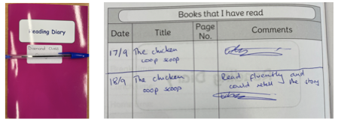

Further to this letter, the teachers of KS1 have produced a YouTube video about reading expectations. Use the link below to view. It has also been posted to your class’ Teams page and the school website:
https://www.youtube.com/watch?v=m2H0J6CInSo

Lost Books
Please take care of the books and your child’s reading zip wallet. If your child’s book is lost, a payment of £3 will be charged to provide them with a new book and purchase a replacement.

If you have any questions about reading with your child, please speak to your child’s teacher.

Happy Reading!

