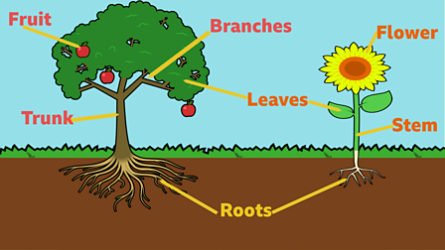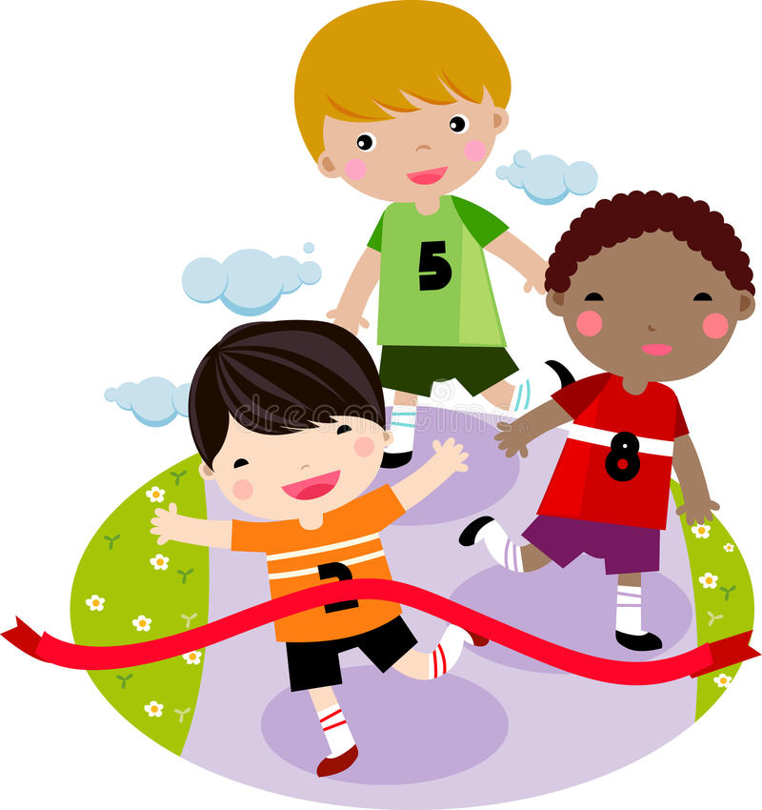

Maths

Children will:

* Count in 2s, 5s and 10s
* Recognise and add equal groups
* Find doubles of numbers
* Share and group sets of dots and objects
* Recognise and find half of an object, shape or amount
* Recognise and find quarter of an object, shape or amount
* Practise turning and following directions

So that they...

Start to count in different multiples

Begin to model multiplication and division questions using real objects and pictorial representation.

Recognise, find, name simple fractions

Describe position, direction and movement including turns

Geography

Children will:

* Explore the local area and the buildings
* Look at pictures and maps of the seaside
* Consider what it would be like to love by the sea

So that they…

Develop knowledge about the UK and the local area

Use geographical vocabulary relating to human and physical features of the sea

Understand that seaside towns are very different to big cities

Science

Children will:

* Explore plants in the local area
* Plant and grow some beans
* Explore the different parts of a plant

So that they…

Identity + name a variety of common wild and garden plant

Identify and describe the basic structure of a variety of common flowering plants including trees

English

Children will:

* Explore ‘Lost and Found’ and other texts by Oliver Jeffers
* Speak in full sentences and recreate their sentences in writing.
* Use pictures and drama to develop ideas for writing
* Write for increasing amounts of time and re-read their work to check for accuracy
* Write character descriptions, stories and “how to” guides
* Take part in Daily Supported Reading
* Have daily phonics or grammar lessons

So that they…

Write in full sentences with appropriate punctuation and letter size

Write for a range of different purposes

Start to edit their work and make improvements

Apply their phonics knowledge when writing and reading

Develop decoding fluency and reading comprehension

Religious Education

Children will:

* Explore places of worship for Muslim and Christian people.
* Discuss similarities and differences between sacred places.

So that they…

Understand what makes some places sacred.

Physical Education

Children will:

* Have weekly indoor and outdoor lessons
* Explore team-building activities
* Develop athletic skills of running, jumping and throwing

So that they…

Develop ideas of sportsmanship and group work

Develop greater stamina and fitness

PSHE

Children will:

* Talk about their families and who is in their family
* Think about friendships they have
* Consider What Makes a Good Friend

So that they…

Appreciate the positive relationships they have in their lives

Can identify qualities that make a good friend and ensure that they themselves are being good friends

Computing

Children will:

* Learn about E-safety and use chrome books
* Make marks with the shape and line tools
* Make choices about colour and style

So that they…

Use shape and line tools on a computer

Use a computer to paint a picture

**Growth**

Music

Children will:

* Explore pitch and tempo
* Create patterns using two pitches
* Create a superhero theme tune

So that they…

Compose and perform a group piece with a changing pitch and tempo, using voices and instruments

How You Can Help

* Support your child with their weekly homework (accessible on the Harbinger website)
* Encourage good hygiene and hand washing habits.
* Read every day with your child using BugClub or books that are sent home.