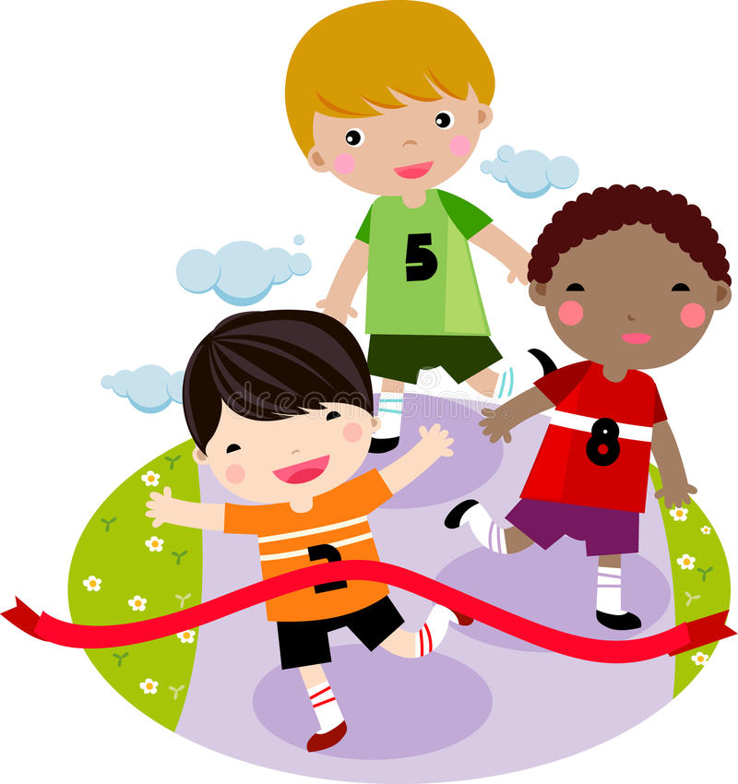

PSHE

Children will:

* Explore the difference between healthy and unhealthy
* Give examples of healthy choices
* Discuss how to stay clean, healthy and safe

So that they…

Know some ways to keep healthy

Understand how to help themselves when they feel poorly

Recognise how being healthy makes them feel happy

Geography

Children will:

* Explore Beijing
* Compare London and Beijing
* Look at photos and videos of two contrasting cities
* Explore land use in the UK and China

So that they…

Develop their knowledge of the world

Understand basic geographical vocabulary relating to human and physical geography

Can talk about the similarities and differences of two areas.

Physical Education

Children will:

* Have weekly indoor and outdoor PE lessons
* Explore movement and dance relating to a theme
* Practise controlling a ball with their hands

So that they…

Create a sequence of movements to music

Control a ball and participate in a range of games

Develop greater stamina and fitness

Music

Children will:

* Explore and copy rhythms with their hands and with instruments
* Listen to different instrument voices

So that they…

Develop an understanding of rhythm and timbre

Create a piece of music representing characters

DT

Children will:

* Design a vehicle
* Measure and cut our components
* Test and improve the finished product

So that they…

Know how to use jigs and handtools for safe, accurate cuts

Describe how their design will appeal to their client

Create a moving vehicle with safety features

Computing

Children will:

* Learn about E-safety
* Log on to Chrome books
* Group and sort data
* Record objects in a group and share information

So that they…

Understand how to stay safe online

Can use ICT to group data and present information

Science

Children will:

* Observe, identify and record signs of

Spring

* Compare winter and spring weather patterns
* Go on a local area walk
* Identify how humans adapt from winter to spring

So that they…

Understand the seasonal changes from winter to spring

Observe and describe weather associated with the seasons and how day length varies

**Healthy**

**Me**

How You Can Help

* Support your child with their weekly homework (accessible on the Harbinger website)
* Encourage good hygiene and hand washing habits.
* Read every day with your child using BugClub or books that are sent home.

English

Children will:

* Explore the texts “Nimesh the adventurer”, “Dinosaurs and all that rubbish” and “Stanley’s stick”
* Write daily for a range of purposes
* Use a Capital letter, finger space and punctuation in every sentence.
* Write a simple sentence using and to combine ideas.
* Use adjectives to describe and add detail
* Take part in Daily Supported Reading
* Have daily phonics or grammar lessons

So that they…

Verbally articulate their ideas clearly and confidently

Write and edit a descriptive setting

Write and edit and publish an information pamphlet

Write and edit a story based on Stanley’s stick

Apply their phonics knowledge when writing and reading

Develop fluency and reading comprehension

Maths

Children will:

* Count from 20 to 50
* Partition numbers in tens and ones
* Estimate numbers on a number line
* Say what is one more and less than a number
* Mesaure objects in cm and m
* Compare and measure the mass, volume and
* Solve one step problems
* Review learnt year 1 maths through regular revision
* Talk about their maths and explain their answers

So that they...

Count with confidence up to 50

Compare length, height, mass, and capacity

Choose and use appropriate standard and non-standard units to measure length, mass and volume