 | w/b 19.2.23 | w/b 26.2.23  Year 1 – Homework activities including regular reading | w/b 4.3.23 | w/b 11.3.23 | w/b 18.3.23 | w/b 25.3.23
English | Watch this video of the poem ‘Nimesh, the Adventurer’ on YouTube. You can use this link  https://www.youtube.com/watch?v=j7rIdQTncGw  Write a description of one of the places Nimesh visits.  For example, the pirate ship, north pole, or park | 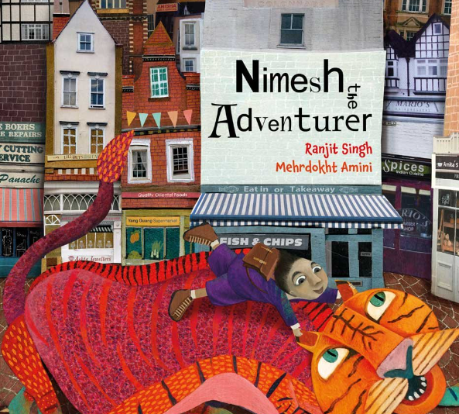  Watch ‘Nimesh, the Adventurer’ again. https://www.youtube.com/watch?v=j7rIdQTncGw  Now re-tell the story. Write it adding lots of detail to make it descriptive. | Write a book review of ‘.  Dinosaurs and All That Rubbish https://www.youtube.com/watch?v=d_huzL_FPZg  - What was it about?  - Did you like it? Why?  - What was your favourite part? | Write a list of instructions on how to look after the earth.  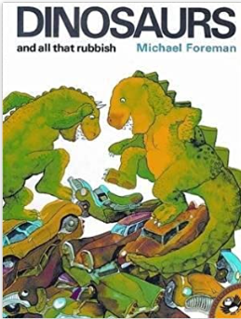 | Re-write your own version of Dinosaurs and All That Rubbish’. ‘  You can keep the story the same or you can change parts if you want. | Think about the story that we have been reading ‘ Dinosaurs and All That Rubbish’  Create a brainstorm- about some dreams and hopes you have for the future.
Maths | Practice some subtracting with numbers up to 20.  For example, 20-8 = 12  Use a number line to help you. | Make a number line from 20-50.  Practice counting along the number line forwards, and backwards between 20 and 50. | Make a number grid to 50 and colour in all the tens.  Can you notice a pattern? Write it in your book.  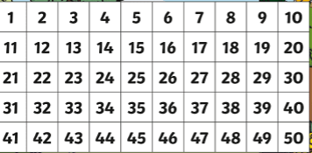 | Answer the following questions using the grid you have previously made.  a) 1 less than 17  b) 1 less than 50  c) 1 more than 2 tens 6 ones d) 1 more than 40 | Compare lengths and heights-using objects in your home.  Draw and compare both in your book.  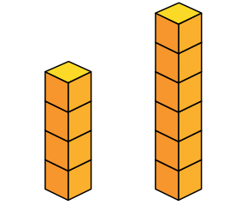 | Look for objects that light and heavy at home. Can you draw the objects and write which one was heavy and light under each object.
Wider Curriculum | Make a poster to show how to stay healthy. Explain why it is important to stay healthy and share all your top tips!  (Food, sleep, exercise, relaxing, staying clean) | Choose a room in your home. Now can you use your imagination to turn it into a different setting, e.g. your living room could become a jungle: your curtains become vines; your table becomes a cave. Can you draw a picture of your new setting? | In Geography we are learning about where we live and our local area. Draw a picture of your local area and label the shops, the plants and buildings.  Can you write a sentence to describe your local area? | In Science we have been learning about seasonal change. Fold a piece of paper into 4 sections, labelling them as ‘Spring’, ‘Summer’ ‘Autumn’ ‘Winter’. In each section, draw and label a picture that represents each season. | Can you draw a silhouette outline of your body (not to scale!) and then colour it in using interesting mixes of colours. | Make a poster to explain what you know about different celebrations are celebrated around the world. Choose one celebration or many celebrations to write about.

Spellings:
These words are taken from the National Curriculum’s Year 1 spelling list – a list of words which children should be able to spell by the end of Year:

- shark  - ship  - park  - seaweed  - Coral reef | - have  - there  - like  - are  - he | - wood  - plastic  - glass  - metal  - water  - rock | - what  - when  - they  - one  - some | - were  - little  - most  - she  - come | - world  - smell  - clean  - dirty  - litter

Number:
Children in Year 1 are expected to count from 20-50.
You can help at home by:
- Practising counting forward and backwards between 1 and 50
- Practising writing numbers to 50 and numerals and words, e.g. 25 twenty-five
- Practising counting in 10s

