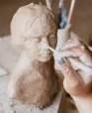
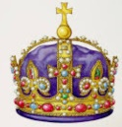
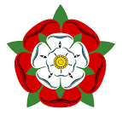
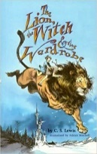
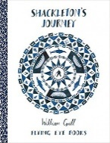





c
RE
Children will:
Learn about what faith looks like today.
So that they…
- Respect the beliefs
of others

Art
Children will:
- Explore different artists and their artistic styles
- Suggests ways to represent memories through imagery, shape and colour
So that they…
- Create a 3D sculpture to express themselves
PE
This half term, we will have outdoor PE every Tuesday and Friday. We are learning Tennis and Challenging Collaborations
Children should come to school with a PE kit which they can change into that includes suitable shoes.

History
Children will:
- Learn about who the Tudors were and when they lived
- Find out how they lived and what they ate
- Explore what life for like for children at that time
- Investigate crime and punishment during that period
So that they…
- Know how the Tudor period began and how it developed over time
- Understand how evidence such as artifacts
help us learn about the Tudors
- Develop their oracy skills
Computing
Children will:
- Create branching databases, first offline and then using online programs
So that they…
- Can use
online programs to gather and
share
information
Music
Children will:
Children will learn about the different elements of traditional Indian Music. Children will use different scales used in traditional Indian music to improvise over a drone.
So that they…
- Develop an appreciation for different musical styles

The Tudors
English
Children will:
- Read and discuss a range of books:

- The Lion the Witch and the Wardrobe
- Shakleton’s Journey

- Build on their ability to write in a descriptive, detailed way
- Use a range of sentence types in their writing, including sentences with subordinate clauses
- Understand the feature of a narrative
- Understand the features of a newspaper report
- Plan, draft, publish and perform poems
So that they…
- Develop a love of reading
- Are able to use their reading skills
to discuss poems and stories
- Can write in a range of genres, and
for different audiences and purposes
- Can edit and improve their writing
- Develop their oracy skills

Science

Children will:
- Revise science topics covered throughout the year
- Study significant scientists and their achievements, linked to the topics covered throughout the year
- Plan and carry out investigations, using a range of scientific skills
- Make predictions and draw conclusions from the experiments they carry out
So that they…
- Can confidently recall information learnt throughout the year
- Understand how scientists work
to gather information
- Can use their scientific
enquiry skills to conduct and
learn from investigations
Maths
Children will:
- Learn how to tell the time to the nearest minute, using both analogue and digital clocks
- Read the time on 12- and 24-hour clocks
- Calculate durations
- Solve problems involving time
- Calculate decimals
- Solve a range of problems involving money
- Interpret and show data and statistics
- Learn about shapes, including angles.
So that they…
- Know how to tell the time
- Can confidently use vocabulary linked to
time, such as AM and PM
- Are able to solve real-world
problems involving the time and money
- Can use a range of tools and units
to measure and show these answer in decimals
- Can read graphs and charts to understand data
Teacher: Nazmeen Ruby CLass Year: 5/5 Term: 3.2 2026

